MAGNOLIA PICTURES, KOTVA FILMS & VERISIMILITUDE
Presents

A MAGNOLIA PICTURES RELEASE

THE WOLFPACK

A film by Crystal Moselle
89 minutes

Official Selection
2015 Sundance Film Festival – Grand Jury Prize: Best Documentary

Twitter: #WolfpackFilm
FB: /thewolfpackdocumentary
http://www.magpictures.com/thewolfpack/

FINAL PRESS NOTES

Distributor Contact: | Press Contact NY/Nat’l: | Press Contact LA/Nat’l:
Matt Cowal | Ryan Werner | Brooke Blumberg
Arianne Ayers | (917) 254-7653 | Sunshine Sachs
Magnolia Pictures | ryan@cineticmedia.com | 8409 Santa Monica Blvd.
(212) 924-6701 phone | Charlie Olsky | West Hollywood, CA 90069
publicity@magpictures.com | charlie@cineticmedia.com | (323) 822-9300 phone
 |  | blumberg@sunshinesachs.com

SYNOPSIS

The six Angulo brothers have spent their entire lives locked away from society in an apartment on the Lower East Side of Manhattan. Nicknamed "The Wolfpack," they're all exceedingly bright, are homeschooled, have no acquaintances outside their family and have practically never left their home. All they know of the outside world is gleaned from the films they watch obsessively and recreate meticulously, using elaborate homemade props and costumes. For years this has served as a productive creative outlet and a way to stave off loneliness - but after one of the brothers escapes the apartment (wearing a Michael Meyers mask for protection), the power dynamics in the house are transformed, and all the boys begin to dream of venturing out. Armed with unprecedented access into the subjects' world and vast archive of home movies, first-time director Crystal Moselle crafts a fascinating portrait of an extraordinary family, capturing the thrill of the Wolfpack's discoveries without skirting the darker questions of abuse and confinement that weigh upon all of them. THE WOLFPACK charts a fascinating coming of age story and becomes a true example of the power of movies to transform and save lives.

DIRECTOR’S STATEMENT – CRYSTAL MOSELLE

It was serendipitous that I met these boys the first week they started going out into the world. It almost felt as if I had discovering a long lost tribe, except it was not from the edges of the world but from the streets of Manhattan. I was moved by their openness, resilience and sense of humor, and I formed a trust with them that could never be duplicated. I have been by their side as they experienced the outside world for the first time, reliving some of my own ‘first’ moments and remembering the excitements and disappointments. It has been an incredible journey for all of us, and it is strange to think that this story could never be told the same way again, with the same sense of innocence and discovery. Their minds and perceptions have already incorporated the rest of the outside world.

- Crystal Moselle

ABOUT ‘THE WOLFPACK’

By ‘The Wolfpack’

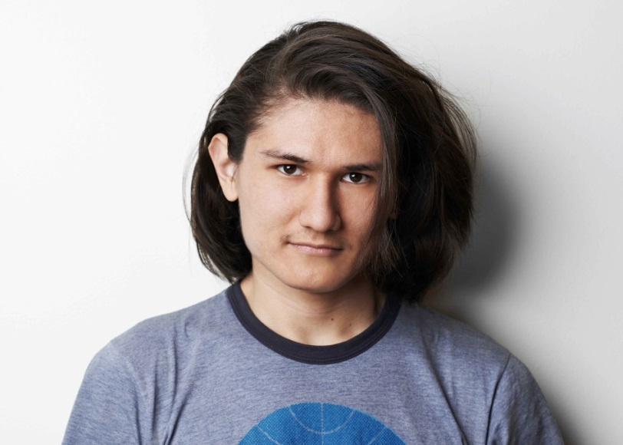
Bhagavan Angulo (23) - The eldest of the brothers, Bhagavan is a gentle soul who finds peace through meditation and yoga. Embodying the need for self-expression, he yearns to perform on stage. He is currently a corp dancer at The Hip Hop Dance Conservatory in NYC as well as a certified Jivamukti Yoga instructor.

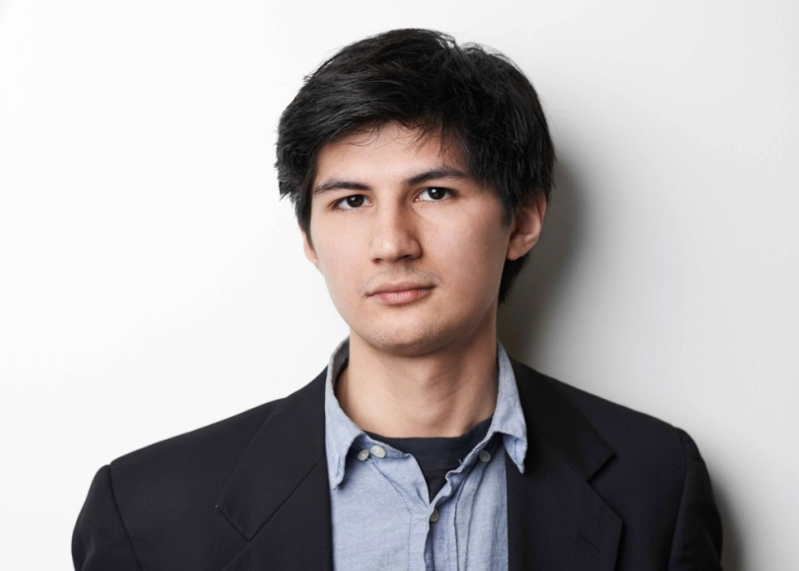
Govinda Angulo (22) - One of the twins and second eldest, Govinda more than anyone aims to assert his individuality from the pack. Perceptive and self-aware, he takes on the role of the lone wolf when he decides to be the first and only to move out of the family home. Govinda now works as an AC on various productions and aspires to be a Director of Photography.

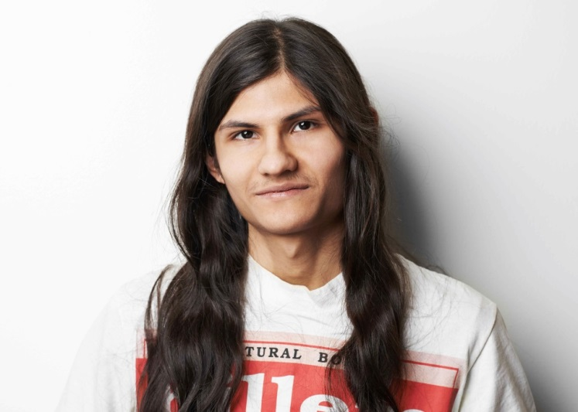
Narayana Angulo (22) – Govinda’s twin is the heart of the family. Narayana’s sensitivity and compassion is unparalleled. He is interested in saving the environment and bringing peace to earth and currently works for NYPIRG, a public advocacy organization. He is a voracious reader and is known as the walking encyclopedia of film trivia amongst the brothers. His films heroes include Orson Welles, David Lynch and Robert Rodriguez and he intends to follow their example as he works throughout every creative field in film.

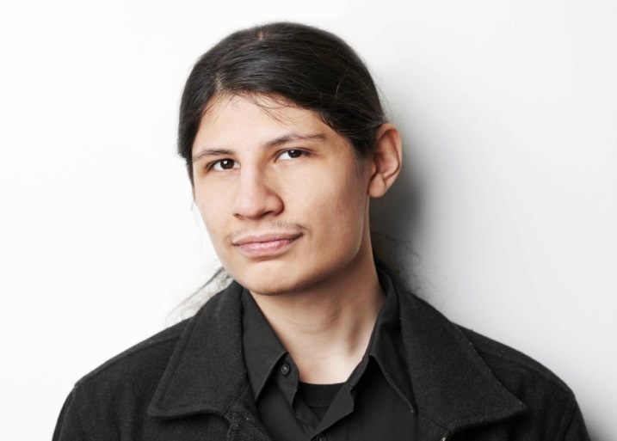

Mukunda Angulo (20) - Considered the unspoken leader and “alpha” of the pack, as well as the first brother to leave the apartment, Mukunda is an aspiring writer / director, and works on various films crews as PA, prop master, and art director assistant. He also works for a media production company, where he does on-set and office PA work. While continuing to making short films and videos and other various projects with his brothers and friends, he looks forward to making a feature film, and is also deciding about changing his last name. His excitement and curiosity are contagious and it is easy to see why when he decides to do something the others follow suit. His favorite holiday is Halloween and he spends nearly the entire month of October preparing for a horror moviethon and unique Halloween celebration.

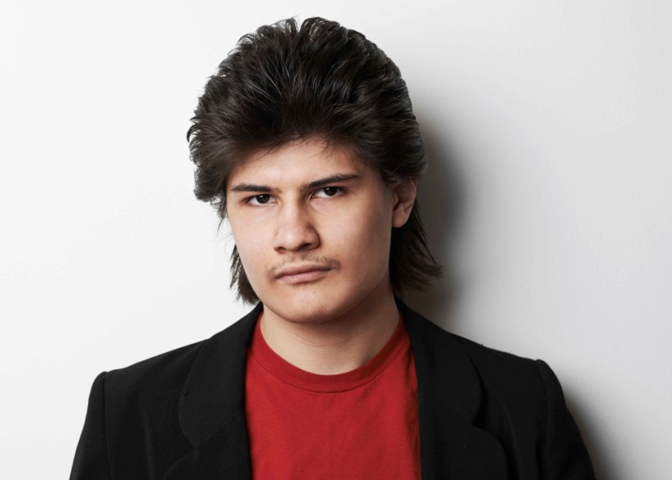
Krsna Angulo (18) – The second to youngest, Krsna has a quirky sense of humor. The passionate actor among his brothers, Krsna loves the spotlight. He and his youngest brother Jagadisa are very into the music culture of the 80’s. He has a deep passion for music and loves to play Rock ‘N’ Roll. Krsna recently changed his name to Glenn Hughes Reisenbichler, inspired by his favorite decade of names (the 80's).

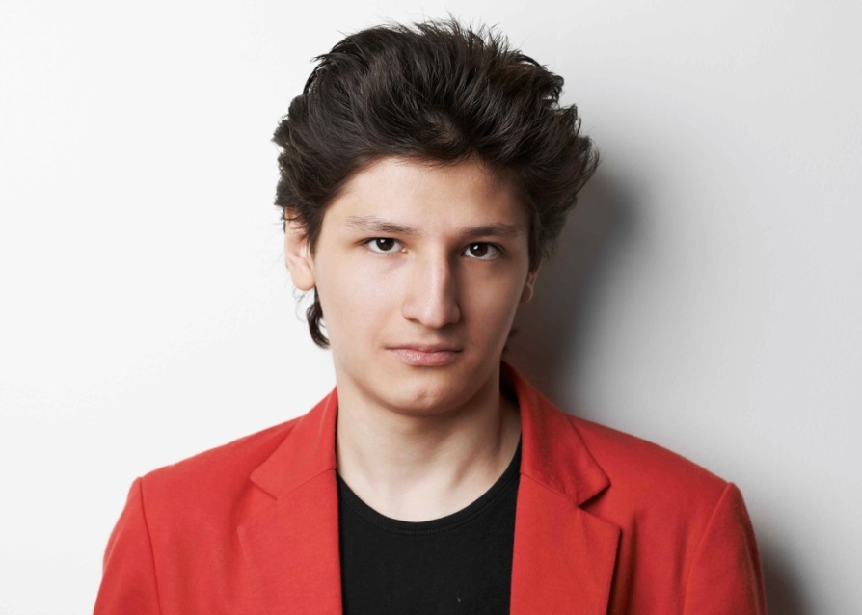
Jagadisa Angulo (16) – The youngest of the pack is also the baddest. Eager to experiment with the vices that the world has to offer, he takes on a cool guy bravado, emphasized by his 80’s attire and hair do’s. He recently changed his given name to Eddie Vaughan Reisenbichler, inspired by his favorite decade of names (the 80's). Most of all he is extremely passionate about music, particularly old time Rock 'N' Roll. He is currently learning to play the guitar, and also plays harmonica.

Visnu Angulo - The eldest and only girl of the siblings is mentally disabled. She loves to sing and stays close to her parents. The brothers’ love for her is unquestionable.

Susanne Angulo - A former hippie from the Midwest, Susanne is the educator and provider of the family. The family lives from the money she receives from the government for caring for her children. She met her husband on the trail to Machu Picchu.

Oscar Angulo - Born in Peru, Oscar aspired to be a musician. He has a deep love for AC/DC, and also made his sons learn to play music. He has an interest in world religion and philosophy.

FAMILY TIMELINE

December 1989 Susanne Meets Oscar in Peru / Oscar offers to lead her and her friends to Machu Picchu / Susanne and Oscar fall in love and move
to the States.

January 1990 Susanne and Oscar travel around the world

April 1990 They go to live in a Hare Krishna Center in West Virginia

October 1990 Visnu is born

August 1991 Baghavan is born in West Virginia

July 1992 Govinda & Narayana are born in West Virginia

1994 The family travels around the country in a van looking for
opportunities for the father to become a rock star.

August 1994 Mukunda is born in Los Angeles while they are still living in the van

March 1995 Family moves to NYC in the Bronx/ Queens / Brooklyn because
they hear that there is cheap housing. Gun shots are heard at their
door and the parents are frightened for their children’s safety

May 1996 Family moves to a housing project in the Lower East Side and
the father forbids mother and children to go out on their own.

January 1997 Krsna is born in NYC

July 1998 Jagadisa is born in NYC

January 2010 Mukunda escapes home wearing a Michael Meyers mask.

April 2010 Brothers start going out of the house together in a pack.

Q&A WITH CRYSTAL MOSELLE

How did you first meet the Angulos, and when did it develop that you would make a documentary about them?

About five years ago, I was cruising down First Avenue in the East Village and these kids with long hair ran past me, weaving through the crowd. I counted one, two three of them…then three more. My instinct took over, and I chased after them catching up at a stop light. I asked where they were from and they said "Delancy Street". They mentioned how they were not supposed to talk to strangers but wondered what I did for a living. When I told them that I was a filmmaker, they got really excited, exclaiming, "we are interested in getting into the business of filmmaking.” We made a time to meet so I could show them some cameras.

This was the start of our friendship. I started filming them here and there while teaching them and encouraging their film endeavors. About 4 months in, I was able to come into their home. This is when I realized there was a deeper story and continued from there – we shot for almost 5 years

How did the boys react to being filmed?

It was a roller coaster. I was dealing with adolescent boys, so I got all sorts of reactions.
When we started, everybody was on board to shoot but it took years to get some of the tender moments where they really opened up. It wasn't easy at times but dealing with teenagers in general isn't easy; I've had experience with this age range before in other projects.

Can you tell us a little bit about your filmmaking work aside from this film? Did any parts of this movie make it into other projects of yours?

I've been doing short form directing for many years. I have worked with Vice, New York Times and Nowness on several projects. I also shoot commercials and music videos.

I did work with the boys on a project for Nowness called "Lightning People" where I followed them around the city in a more artful way.

How did the parents take to being filmed? Were they worried at all about how they may have appeared, as their children had been in their apartment for so long?

The parents were open to the idea of documenting their family - I feel like they saw opportunity for their children. I'm not sure they realized how in-depth the project would get. I think there was some anxiety from each of them over the film, but they were always open and wiling to film. Now that they have seen the movie there is nothing but positive enthusiasm for the project from both of them.

When filming, were you tempted to intervene in the boys’ lives in any way, or help them get out of their apartment?

When I came into these boys lives there was nothing that alarmed me about the situation. They seemed stable, well cared for and educated by their parents (especially their mother). If I had come one year earlier things may have been different. Also, at the point I came into the story the boys had started their rebellion against their father and the power in the household had shifted. They did not seem to need or desire for me to intervene.

What I did do was to encourage them explore their interest in filmmaking, by helping them to get internships and introduce them to people in the film industry.

In the movie, the boys make an obvious progression, starting as very isolated characters but thrilled to learn more about the outside world. The mother seems to undergo a bit of a similar transformation – nervously testing her limits. How did she seem to progress from when you started shooting to when you ended?

Susanne feels like a different person to me now. When we first met she was more submissive and reserved. I think her children's step towards freedom and socialization really helped her stand up for her own rights as well. It's a process but she is well on the right path to gaining her own independence.

In the film, we see the boys’ sister Vishnu, but we don’t hear too much about her. Can you tell us a little bit of her story? Why did you decide not to use much of it in the final film?

Visnu has Turner’s Syndrome, which is a genetic condition in which a female does not have the usual pair of two X chromosomes. She can’t communicate as well as the others, and the film really shaped up as the story about the brothers breaking free. She was of course a part of it and is very much a part of the family. They have a really wonderful relationship with her - they take her to the beach and include her in their Halloween festival every year.

It’s interesting to see what an advanced aesthetic the boys have in the movie for people who are so isolated - both in their movie taste and their personal style. How did they end up seeing so many movies and where did they develop their personal wardrobes to that extent?

Their dad brought both classic and cult movies to them. They liked the violent, horrific, morally complicated films the best. As they read more about movies they started to request specific films.

The boys first saw PULP FICTION on television, and this started their Quentin Tarantino obsession. It opened their eyes to film outside the realms of the standard Hollywood films they were used to watching. Since films were their world, they started to interpret these looks into their wardrobe. Their personal style is directly related to their favorite characters from their favorite movies. A lot of their early costumes were from clothing their dad would find on the street and at Salvation Army, which they would re-work by hand into specific costumes. For example, they’d tape blue Nike swooshes on tennis
shoes to look like Marty McFly’s, or cut up a woman's rain coat and sew it into the shape of Mad Max's leather biker vest.

ABOUT THE FILMMAKERS

CRYSTAL MOSELLE (Director) is a New York-based director working with short form storytelling for the past decade. Her series “Something Big, Something Small” featuring Pharrel Williams, Aurel Schmidt, and Shepard Fairey was picked up by The New York Times. She also produced the feature documentary, EXCAVATING TAYLOR MEAD, a portrait of the downtown artist and Warhol Superstar which was part of the 2006 Whitney Biennial. THE WOLFPACK is her first feature length documentary.

IZABELLA TZENKOVA (Producer) is a film and digital media producer. Izabella’s credits include the feature films THE ATHLETE and LILY, both narratives based on true stories.

ENAT SIDI (Editor) is very active as an Emmy Award-winning editor. Born and raised in Tel Aviv, she is a frequent collaborator with directors Heidi Ewing and Rachel Grady, having edited most of their nonfiction feature films including the 2005 Emmy® nominee THE BOYS OF BARAKA, the 2006 Academy Award nominee JESUS CAMP, the HBO Peabody® winner 12TH & DELAWARE and most recently DETROPIA, for which Enat won the editing award at the 2012 Sundance Film Festival and an Emmy for editing. Enat acted as the consulting editor on BULLY, the high profile documentary released in 2012 by the Weinstein Company.

HUNTER GRAY (Producer) is a partner and producer at Verisimilitude. Most recently, Hunter Gray produced Mike Cahill’s I ORIGINS and Carter Smith’s JAMIE MARKS IS DEAD, which both premiered at the 2014 Sundance Film Festival. Past producing credits include ANOTHER EARTH, TERRI, MOMMA’S MAN, and HALF NELSON.

ALEX ORLOVSKY (Producer) is a film producer and partner at Verisimilitude. Orlovsky’s most recent producing credits include, Mike Cahill’s I ORIGINS and Carter
Smith’s JAMIE MARKS IS DEAD which both premiered at the 2014 Sundance Film Festival. His past producing credits include THE PLACE BEYOND THE PINES, BLUE VALENTINE, TERRI, MOMMA’S MAN and HALF NELSON.

DAVID CROSS (Executive Producer) is a comedian, actor, writer and voice artist known primarily for his standup work, the HBO sketch comedy series Mr. Show and his role as Tobias Fünke in the sitcom Arrested Development. Cross created, wrote, executive produced, and starred in The Increasingly Poor Decisions of Todd Margaret; developed and had a prominent role in the Comedy Central animated sitcom Freak Show; and has a recurring role in the ABC sitcom Modern Family. Cross portrayed Ian Hawke in the live-action/CGI ALVIN AND THE CHIPMUNKS films.

TYLER BRODIE (EXECUTIVE PRODUCER) is a founding partner of the production companies, Verisimilitude and Artists Public Domain. Tyler recently executive produced ANOTHER EARTH, TERRI and THE FORGIVENESS OF BLOOD. His past executive producer credits include PI, THE BALLAD OF RAMBLIN’ JACK, YOU SEE ME
LAUGHING’, MEMORIAL DAY, VOY A EXPLOTAR, ZERO BRIDGE and MOMMA’S MAN. Tyler is also co-owner of New York-based record labels WHAT’S YOUR RUPTURE? and DFA RECORDS.

DANNY BENSI & SAUNDER JURIAANS (Composers) are multi-instrumentalists and classically trained musicians. They began their film scoring career with Alistair
Banks Griffin's TWO GATES OF SLEEP (Cannes - Director's Fortnight, 2010), and have since moved on to score various features and shorts including Sean Durkin's MARTHA
MARCY MAY MARLENE (Sundance, 2011 - winner best director, Cannes - Official
Selection, 2011), Ruben Ostlund's PLAY (Cannes - Director's Fortnight, 2011), PBS
American Experience THE AMISH and Antonio Campos' SIMON KILLER (Sundance,
2012).

CREDITS

A KOTVA FILMS and VERISIMILITUDE present

Directed by
CRYSTAL MOSELLE

Edited By
ENAT SIDI

Produced By
IZABELLA TZENKOVA
CRYSTAL MOSELLE

Producers
HUNTER GRAY
ALEX ORLOVSKY

Executive Producers
TYLER BRODIE
LOUISE INGALLS STURGES

Executive Producers
CAMERON BRODIE
DAVID CROSS

Co-Producers
RENÉ SASCHA JOHANNSEN
BEN SNYDER

Associate Producers
MEGAN DELANEY
TRACE HENDERSON
Music Supervision By
RANDALL POSTER
MEGHAN CURRIER

Camera
CRYSTAL MOSELLE

Additional Camera
ANTONIO FERRARA
MARISSA KAISER
JAKE CARL MAGEE
RENÉ SASCHA JOHANNSEN
MUKUNDA ANGULO
NARAYANA ANGULO
GOVINDA ANGULO
ALEXANDER DYNAN
WAYNE YIP

Sound Recordists
RICHARD LEVENGOOD
COLE WENNER

Additional Cast
CHLOE PECORINO

Production Assistants
CASSIE DAVIS
JANIE GILARDE
REBECCA WEBER
SARAH GRECO

Post Production Supervisor
TRACE HENDERSON

Additional Editor
RENÉ SASCHA JOHANNSEN

Assistant Editor
RYAN BALAS

Post Production Assistant
LUCIE ELWES

Edit Interns
HANNA FARZIN
ANNA POLLACK

Post Production Sound Services Provided by
GIGANTIC STUDIOS

Dialogue Editor
ESTHER REGELSON

Effects Editor
CHRIS DAVIS

Re-recording Mixer
TOM PAUL

Foley Artist
ERIC MILANO

Foley Recordist
CHRIS DAVIS

Executive Producer
STEVEN TOLLEN

Digital Intermediate Provided by
FINAL FRAME POST

DI Colorist
WILL COX

DI Online Editor
OWEN RUCKER

DI Producer
CAITLIN TARTARO

Music Coordinator
RACHEL SIPSER

Titles and Graphics
EÓIN MACMANUS
LAURENCE JACCOTTET

Production Counsel
GRAY KRAUSS STRATFORD SANDLER DES ROCHERS LLP
ANDRÉ DES ROCHERS, ESQ.
JESSE FOX, ESQ.
BIANCA GRIMSHAW, ESQ.

Clearance Counsel
DONALDSON AND CALLIF LLP
DEAN R. CHELEY, ESQ.

Distribution Advisor
JOSH BRAUN / SUBMARINE ENTERTAINMENT

Camera Equipment Provided by
CANON

Lighting Equipment Provided by
PRODUCTION JUNCTION
Music Recorded and mixed at
PULSE STUDIOS NYC

Music
“THIS IS HALLOWEEN”
WRITTEN BY DANNY ELFMAN
PERFORMED BY THE CITIZENS OF HALLOWEEN TOWN
PUBLISHED BY BUENA VISTA MUSIC COMPANY
COURTESY OF WALT DISNEY RECORDS
“DAYLIGHT [FEAT. SIGNE MARIE SCHMIDT-JACOBSEN]”
WRITTEN BY PEDER THOMAS PEDERSEN, RASMUS OLSEN, ASGER BADEN.
PERFORMED BY PEDER
PUBLISHED BY KODA/COPYRIGHT CONTROL
COURTESY OF FAKE DIAMOND RECORDS

“TARZAN BOY”
WRITTEN BY MAURIZIO BASSI AND NAIMY HACKETT
PERFORMED BY BALTIMORA
PUBLISHED BY EMI BLACKWOOD MUSIC INC. ON BEHALF OF EMI MUSIC
PUBLISHING ITALIA S.R.L.(BMI)
COURTESY OF EMI MUSIC ITALY UNDER LICENSE FROM UNIVERSAL MUSIC
ENTERPRISES

“END OF THE BEGINNING”
WRITTEN BY OZZY OSBOURNE, TONY IOMMI AND TERRENCE BUTLER
PERFORMED BY BLACK SABBATH
PUBLISHED BY BLIZZARD MUSIC LIMITED (ASCAP) AND BMG GOLD SONGS
(ASCAP)
COURTESY OF BS PRODUCTIONS/REPUBLIC RECORDS UNDER LICENSE FROM
UNIVERSAL MUSIC ENTERPRISES

“WHO TOOK BERLIN (PART I)”
PERFORMED BY DANNY BENSI, SAUNDER JURRIAANS, AND GREG ROGOVE
WRITTEN BY DANNY BENSI, SAUNDER JURRIAANS, AND GREG ROGOVE
COURTESY OF DANNY BENSI, SAUNDER JURRIAANS, AND GREG ROGOVE
“THE CENTURY TRILOGY I: CONQUEST”
WRITTEN BY DANNY BENSI, SAUNDER JURRIAANS, AND GREG ROGOVE
PERFORMED BY DANNY BENSI, SAUNDER JURRIAANS, AND GREG ROGOVE
COURTESY OF DANNY BENSI, SAUNDER JURRIAANS, AND GREG ROGOVE

Additional Material
'RESERVOIR DOGS'/LIVE ENTERTAINMENT/MIRAMAX FILMS/QUENTIN TARANTINO
‘STUCK IN THE MIDDLE WITH YOU’/ WRITTEN BY GERRY RAFFERTY/JOE
EGAN/PERFORMED BY STEALERS WHEEL/PUBLISHED BY BMG AND BABY RUN /
COURTESY OF UNIVERSAL RECORDS
'PULP FICTION'/MIRAMAX FILMS/QUENTIN TARANTINO
'SCREAM'/DIMENSION FILMS/WES CRAVEN
'ALL YOU NEED IS LOVE'/LENNON-MCCARTNEY/SONY/ATV TUNES LLC
'THE DARK KNIGHT'/WARNER BROS./CHRISTOPHER NOLAN
'THE DARK KNIGHT RISES'/WARNER BROS./CHRISTOPHER NOLAN
'HALLOWEEN'/COMPASS INTERNATIONAL PICTURES/JOHN CARPENTER

Special Thanks
AVIVA YAEL
WAYNE YIP
JAURETSI SAIZARBITORIA
ALEXANDRA HANNIBAL
RYAN HARRINGTON
JOSE RODRIGUEZ
CODIE BROOKES
TURNER TURNER
DAN MARTENSON
EOIN MACMANUS
LEA DITSON
CHARLES MOSELLE
ALEX YENNI
PETE MACIA
PATRICK SHER
LYZ OLKO
NED SHATZER
DAVE MCGRATH
CHRIS EDWARDS
AHMAD BHILAL
DAVE SCHNAPPER
VIVAN THI TANG

This Film is Supported by
TFI DOCUMENTARY FUND
TFI/A&E INDIEFILMS STORYLAB
THE JEROME FOUNDATION

www.thewolfpackfilm.com
Copyright Wolfpack Project, LLC

